**IMPLEMENTATION OF PING COMMAND**

**AIM**

To implement ping client server program

**ALGORITHM:**

**SERVER:**

1.START

2.Deaclare variables for Socket and Specify port Number.

3.Generate the response from Destination IP address as acknowledgement to packets received.

4.Send it to the Client side.

5.Close the Connection.

6.STOP

**CLIENT:**

1.START

2.Declare variables for Socket.

3.Specify the Port Number and IP address.

4.Scan the input of number of packets and IP address to be pinged.

5.Read responses from Server.

6.Close the Connection

7.STOP

**SOURCE CODE**

**Ping client server program**

PingServer.java

import java.io.*;

import java.net.*;

import java.util.*;

public class PingServer

{

public static void main(String[] args)

{

try

{

ServerSocket ss=new ServerSocket(2156);

Socket s=ss.accept();

if(s.isConnected())

System.out.println("Connected ...");

System.out.println("Listening ...");

DataInputStream dis=new DataInputStream(s.getInputStream());

DataOutputStream dos=new DataOutputStream(s.getOutputStream());

int no=0;

String ip="";

if((dis.readUTF()).equals("P"))

{

System.out.println("Getting No. Of Packets ...");

no=dis.readInt();

}

if((dis.readUTF()).equals("A"))

{

System.out.println("Getting the Address ...");

ip=dis.readUTF();

}

Process p=Runtime.getRuntime().exec("ping -c "+no+" "+ip);

System.out.println("Running ping -c "+no+" "+ip);

BufferedReader br=new BufferedReader(new

InputStreamReader(p.getInputStream()));

String ipline=br.readLine();

while(ipline != null )

{

dos.writeUTF(ipline);

ipline=br.readLine();

}

dis.close();

dos.close();

}catch(Exception x)

{

x.printStackTrace();

}

}

}

**PingClient.java**

import java.io.*;

import java.net.*;

import java.util.*;

public class PingClient

{

public static void main(String[] args)

{

try

{

Socket s=new Socket("localhost",2156);

BufferedReader br=new BufferedReader(new InputStreamReader(System.in));

if(s.isConnected())

System.out.println("Connected !!");

Scanner in=new Scanner(System.in);

DataInputStream is=new DataInputStream(s.getInputStream());

DataOutputStream os=new DataOutputStream(s.getOutputStream());

System.out.println("How many Packets You want to send ? ");

int no=in.nextInt();

System.out.println("Address to be pinged :");

String ip=br.readLine();

os.writeUTF("P");

os.writeInt(no);

os.writeUTF("A");

os.writeUTF(ip);

String pingline=is.readUTF();

while(pingline != null )

{

System.out.println(pingline);

pingline=is.readUTF();

}

os.flush();

os.close();

is.close();

}catch(Exception x)

{

}

}

}

**OUTPUT**

PingServer.java

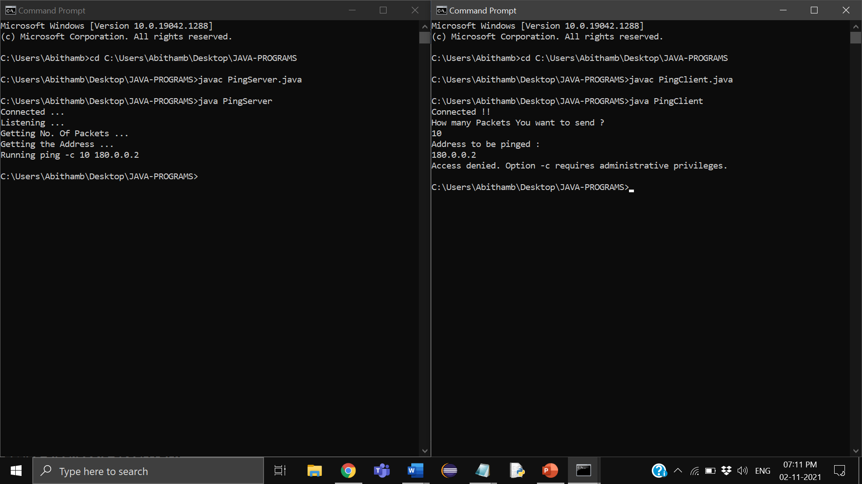

PingClient.java



**RESULT**

Hence ping client server program is implemented.